Test Case: tc001_SPX_Dev5_Crear_Nueva_Linea_Requisicion_Spot_Tipo_Cobro_CC
Step 1 - Enter username and password and click to button Enter : Credentials Entered
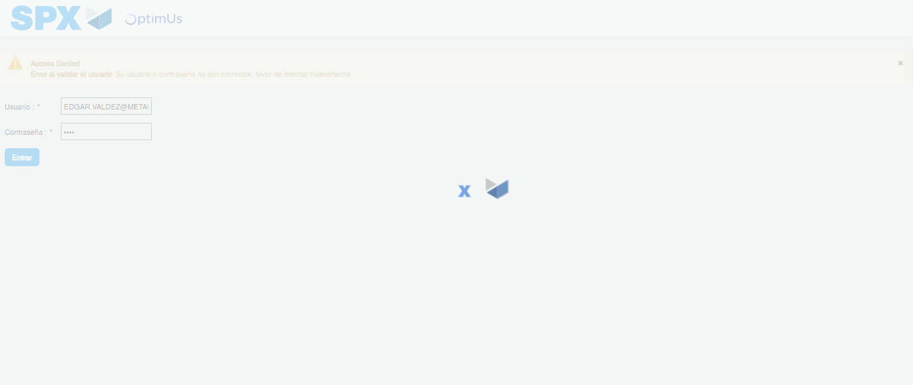Image file-name: QC_Testing-tc001_SPX_Dev5_Crear_Nueva_Linea_Requisicion_Spot_Tipo_Cobro_CC-1781315250891

Step 2 - Select to UEN and Access to Spot Buy Requisitions : UEN Correctly selected and Correct access
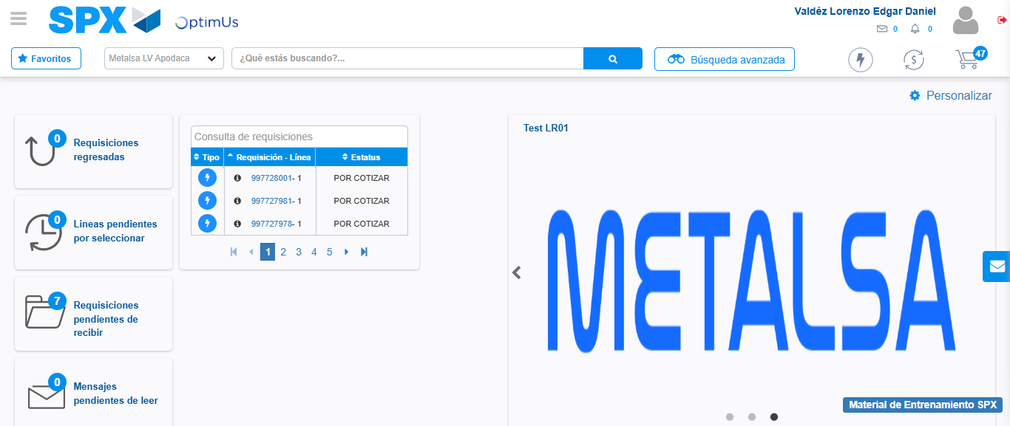Image file-name: QC_Testing-tc001_SPX_Dev5_Crear_Nueva_Linea_Requisicion_Spot_Tipo_Cobro_CC-1781315276676

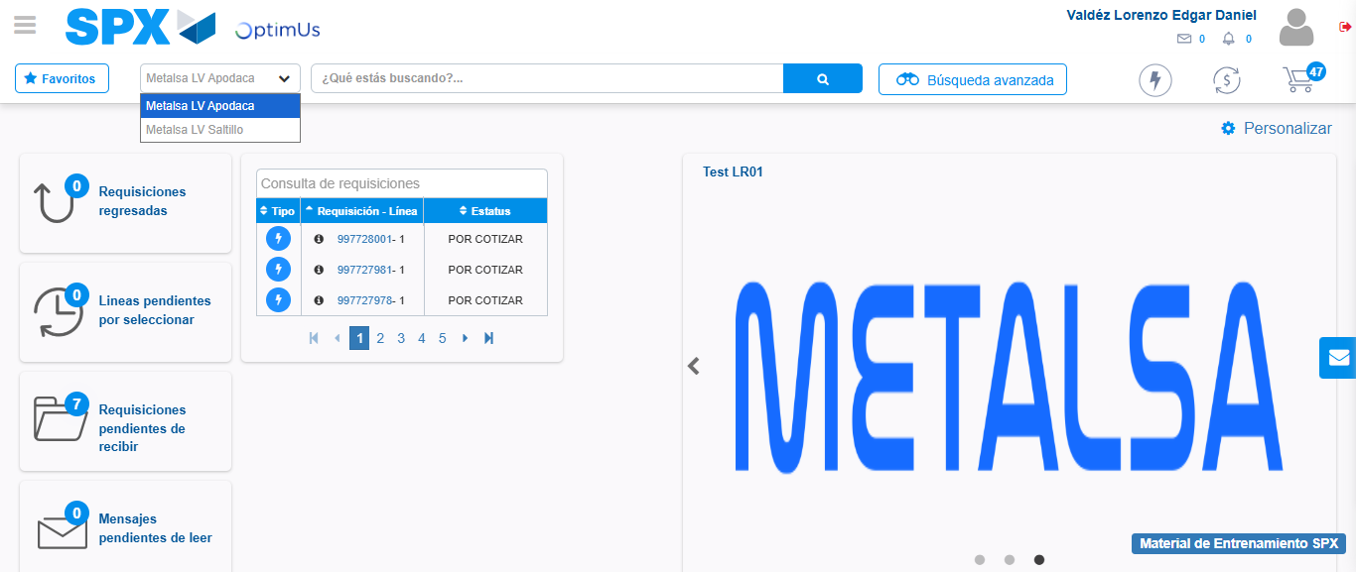Image file-name: QC_Testing-tc001_SPX_Dev5_Crear_Nueva_Linea_Requisicion_Spot_Tipo_Cobro_CC-1781315279401

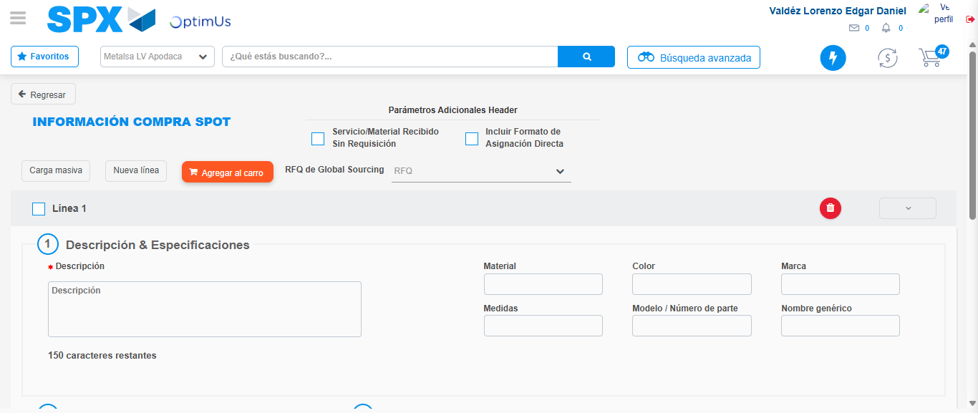Image file-name: QC_Testing-tc001_SPX_Dev5_Crear_Nueva_Linea_Requisicion_Spot_Tipo_Cobro_CC-1781315297889

Step 3 - Data Capture Spot Buy Requisition: Data captured correctly
Image file-name: QC_Testing-tc001_SPX_Dev5_Crear_Nueva_Linea_Requisicion_Spot_Tipo_Cobro_CC-1781315298126

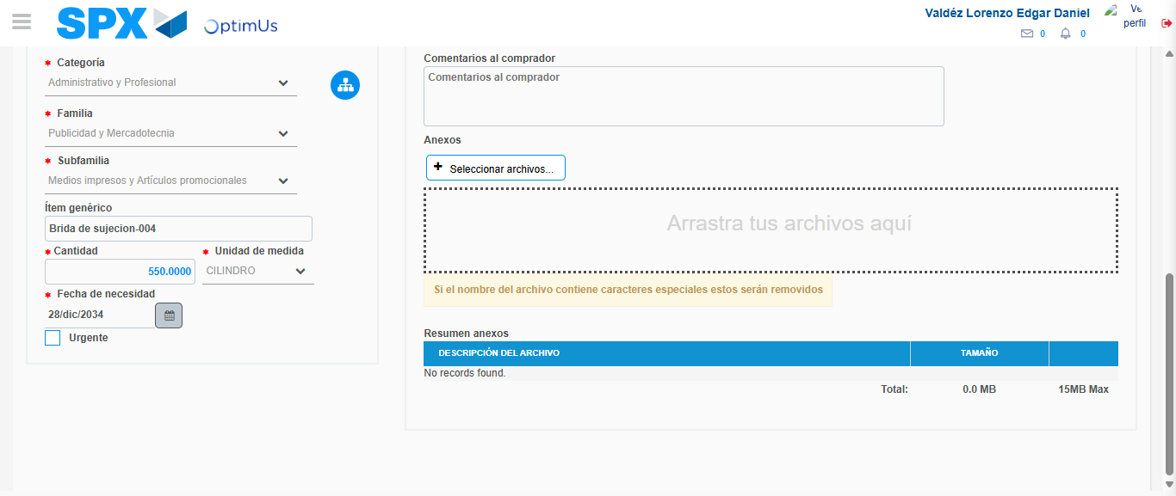Image file-name: QC_Testing-tc001_SPX_Dev5_Crear_Nueva_Linea_Requisicion_Spot_Tipo_Cobro_CC-1781315310498

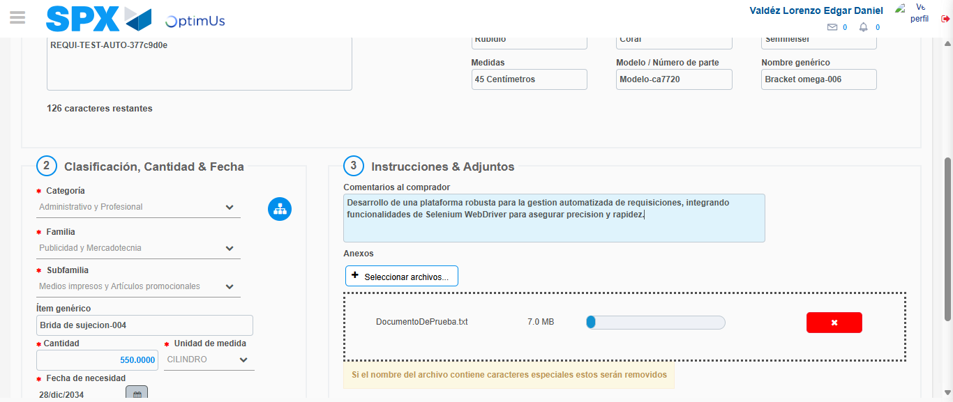Image file-name: QC_Testing-tc001_SPX_Dev5_Crear_Nueva_Linea_Requisicion_Spot_Tipo_Cobro_CC-1781315311456

Step 4 - Add new line and data capture second line: Line add correctly
Image file-name: QC_Testing-tc001_SPX_Dev5_Crear_Nueva_Linea_Requisicion_Spot_Tipo_Cobro_CC-1781315298126

Image file-name: QC_Testing-tc001_SPX_Dev5_Crear_Nueva_Linea_Requisicion_Spot_Tipo_Cobro_CC-1781315310498

Image file-name: QC_Testing-tc001_SPX_Dev5_Crear_Nueva_Linea_Requisicion_Spot_Tipo_Cobro_CC-1781315311456

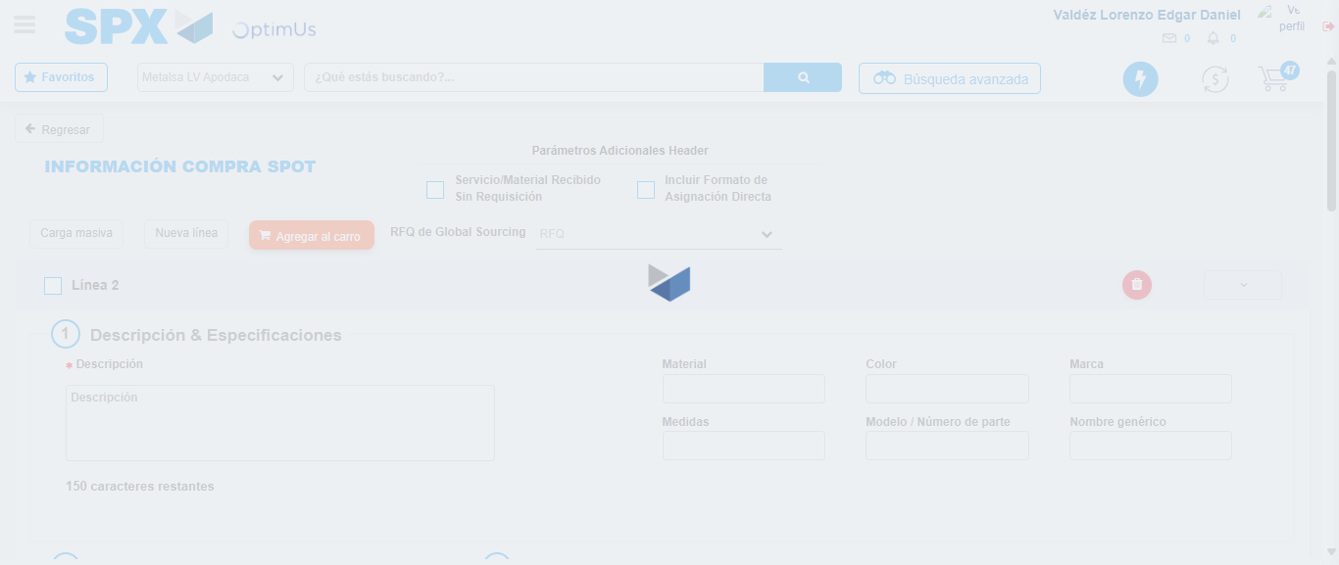Image file-name: QC_Testing-tc001_SPX_Dev5_Crear_Nueva_Linea_Requisicion_Spot_Tipo_Cobro_CC-1781315313940

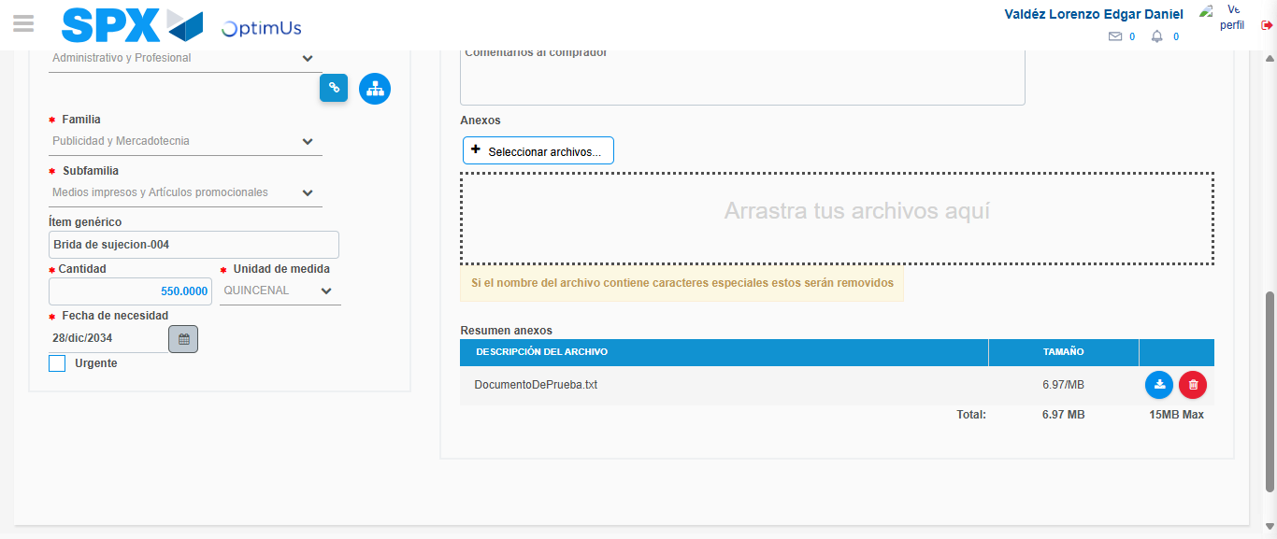Image file-name: QC_Testing-tc001_SPX_Dev5_Crear_Nueva_Linea_Requisicion_Spot_Tipo_Cobro_CC-1781315324482

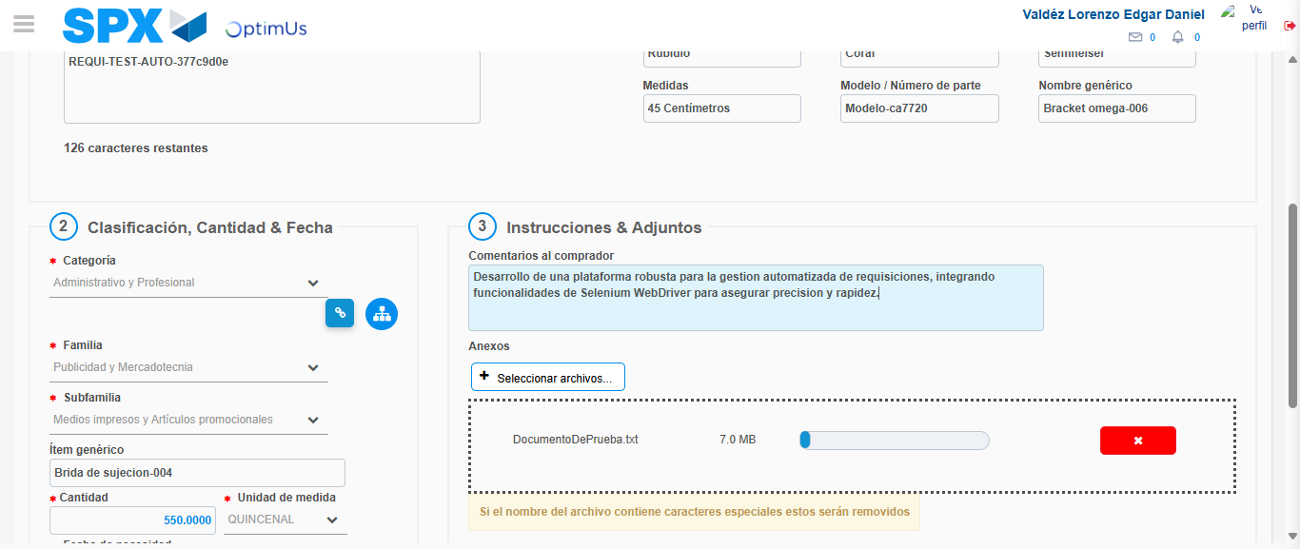Image file-name: QC_Testing-tc001_SPX_Dev5_Crear_Nueva_Linea_Requisicion_Spot_Tipo_Cobro_CC-1781315325439

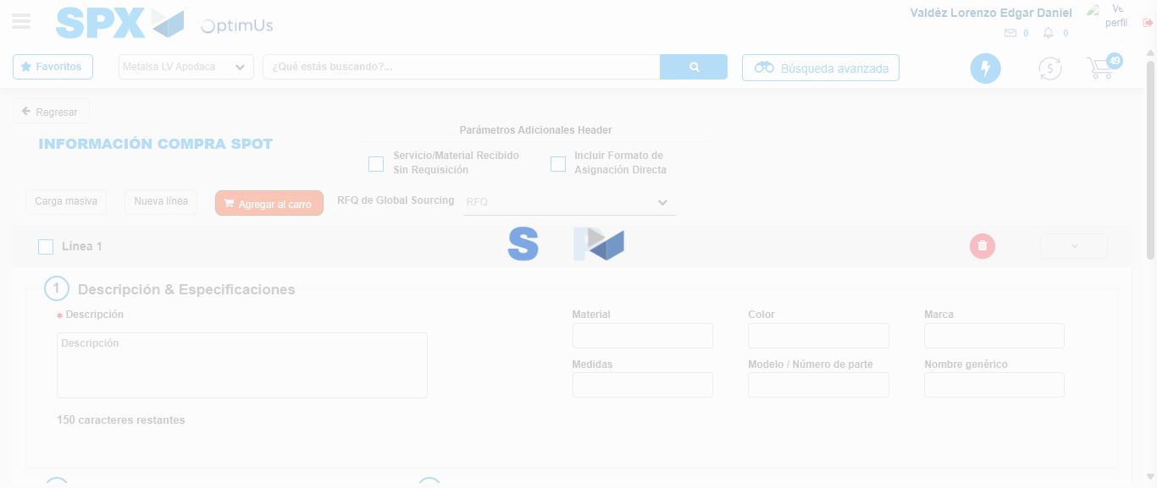Image file-name: QC_Testing-tc001_SPX_Dev5_Crear_Nueva_Linea_Requisicion_Spot_Tipo_Cobro_CC-1781315336412

Step 5 - Select to Requisition: Requisition Correctly selected
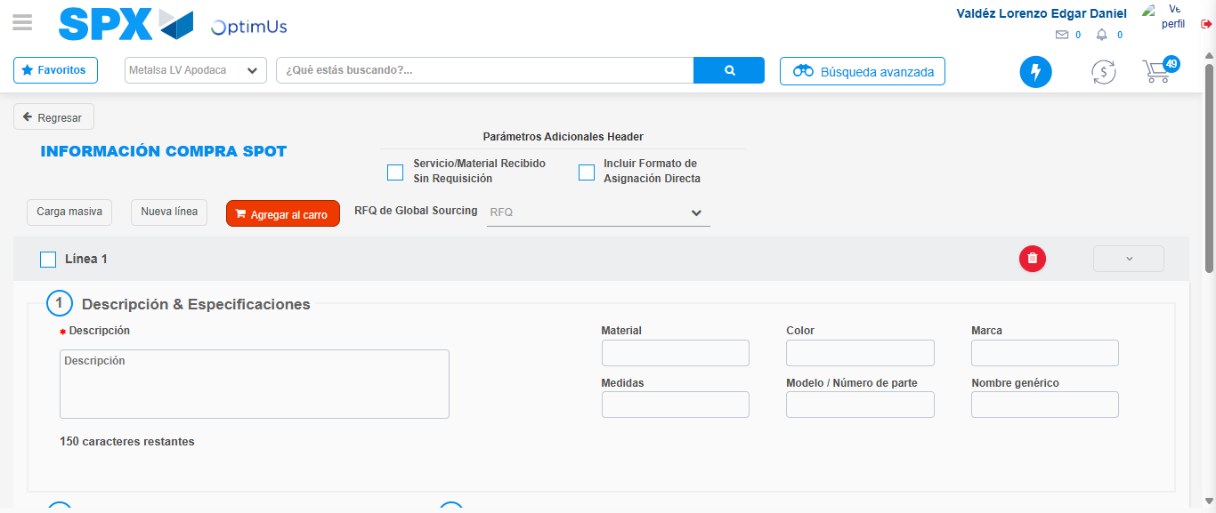Image file-name: QC_Testing-tc001_SPX_Dev5_Crear_Nueva_Linea_Requisicion_Spot_Tipo_Cobro_CC-1781315336588

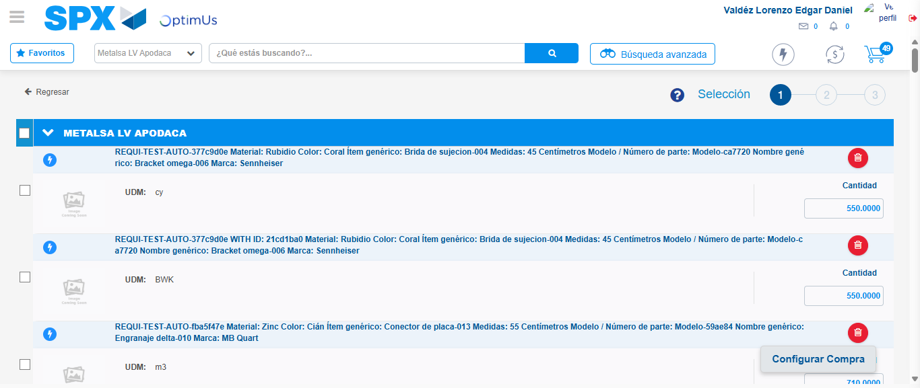Image file-name: QC_Testing-tc001_SPX_Dev5_Crear_Nueva_Linea_Requisicion_Spot_Tipo_Cobro_CC-1781315341840

Image file-name: QC_Testing-tc001_SPX_Dev5_Crear_Nueva_Linea_Requisicion_Spot_Tipo_Cobro_CC-1781315342054

Image file-name: QC_Testing-tc001_SPX_Dev5_Crear_Nueva_Linea_Requisicion_Spot_Tipo_Cobro_CC-1781315342218

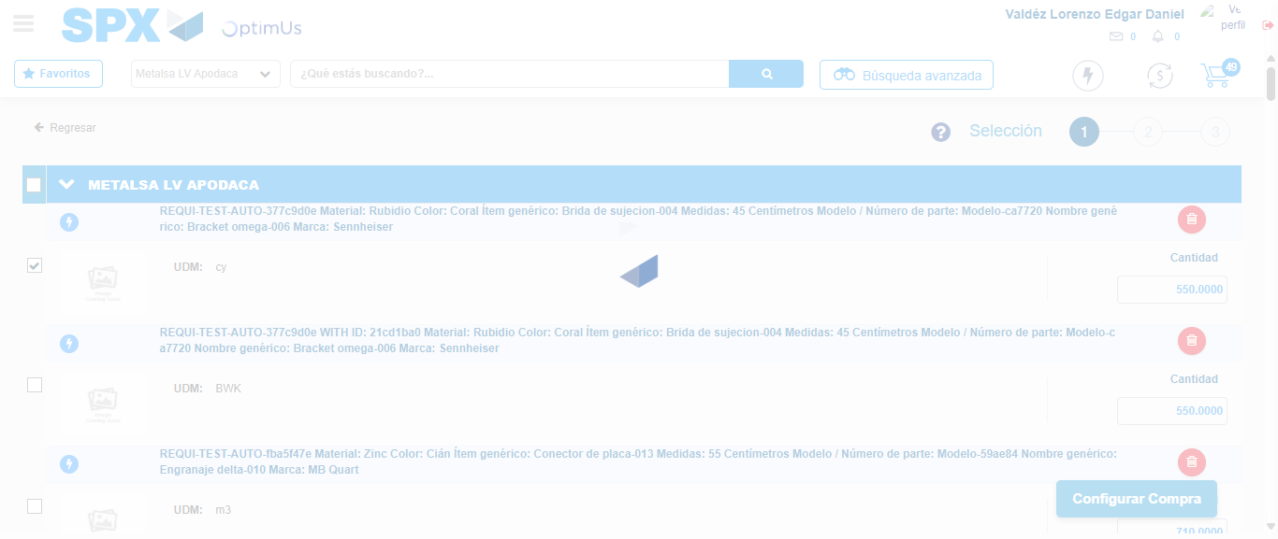Image file-name: QC_Testing-tc001_SPX_Dev5_Crear_Nueva_Linea_Requisicion_Spot_Tipo_Cobro_CC-1781315343143

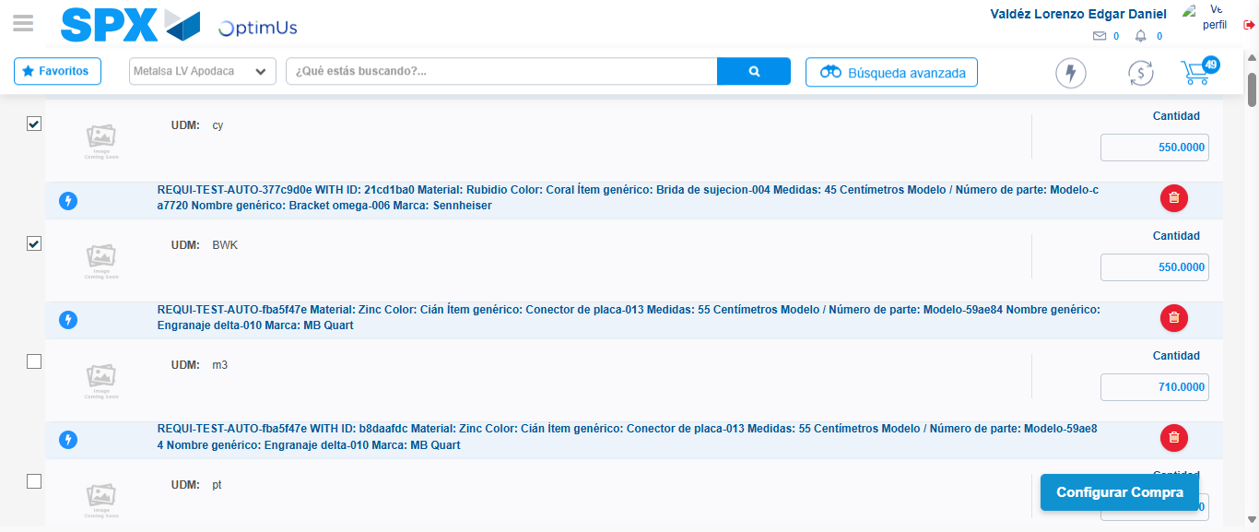Image file-name: QC_Testing-tc001_SPX_Dev5_Crear_Nueva_Linea_Requisicion_Spot_Tipo_Cobro_CC-1781315344065

Step 6 - Select Type Account For Requisition: Type Account Correctly selected
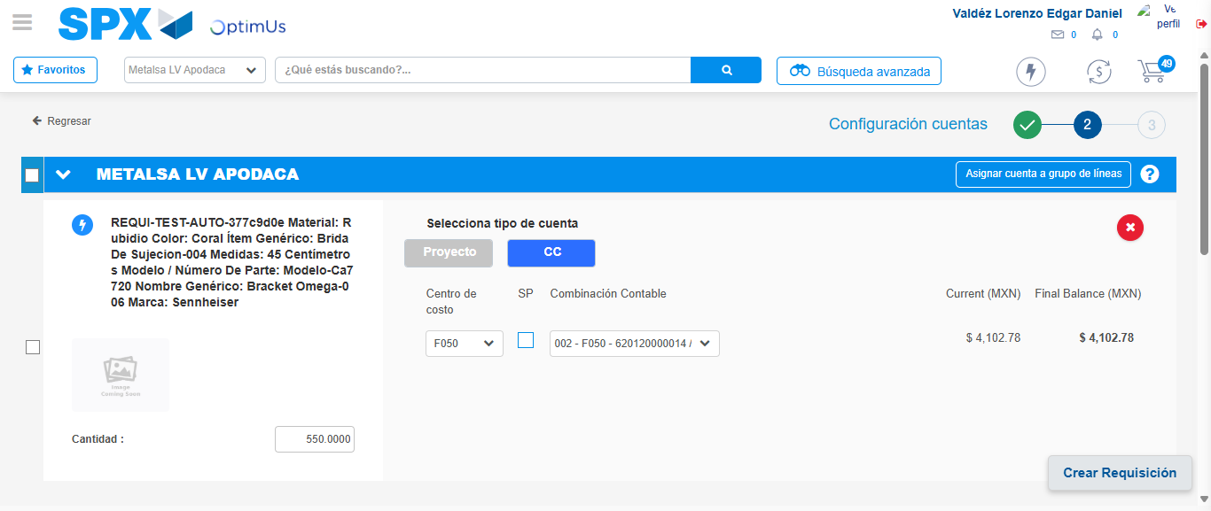Image file-name: QC_Testing-tc001_SPX_Dev5_Crear_Nueva_Linea_Requisicion_Spot_Tipo_Cobro_CC-1781315356051

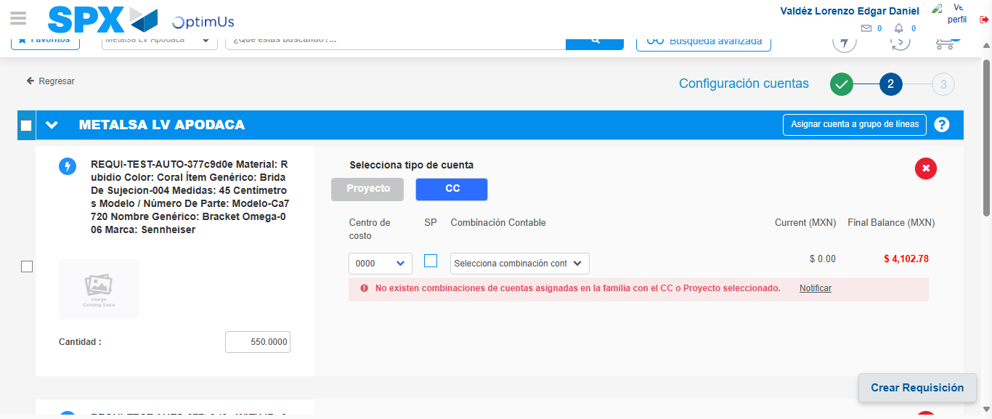Image file-name: QC_Testing-tc001_SPX_Dev5_Crear_Nueva_Linea_Requisicion_Spot_Tipo_Cobro_CC-1781315366877

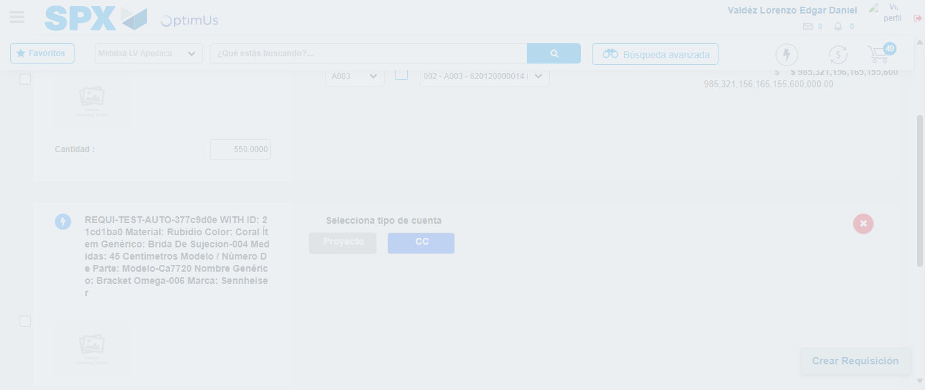Image file-name: QC_Testing-tc001_SPX_Dev5_Crear_Nueva_Linea_Requisicion_Spot_Tipo_Cobro_CC-1781315375150

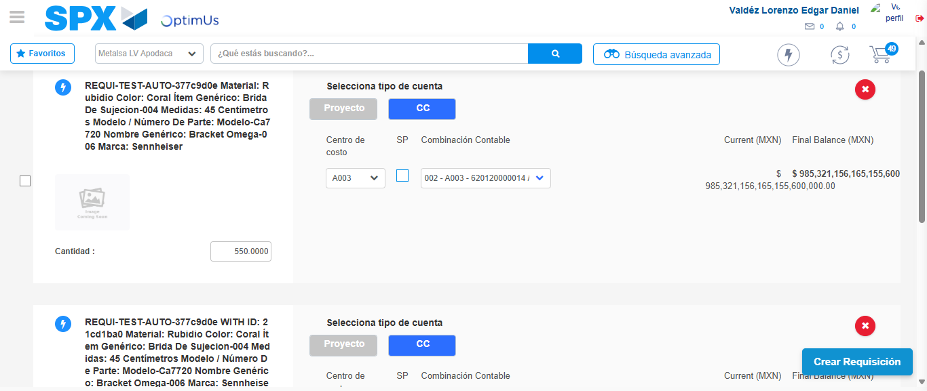Image file-name: QC_Testing-tc001_SPX_Dev5_Crear_Nueva_Linea_Requisicion_Spot_Tipo_Cobro_CC-1781315384084

Image file-name: QC_Testing-tc001_SPX_Dev5_Crear_Nueva_Linea_Requisicion_Spot_Tipo_Cobro_CC-1781315386398

Image file-name: QC_Testing-tc001_SPX_Dev5_Crear_Nueva_Linea_Requisicion_Spot_Tipo_Cobro_CC-1781315386607

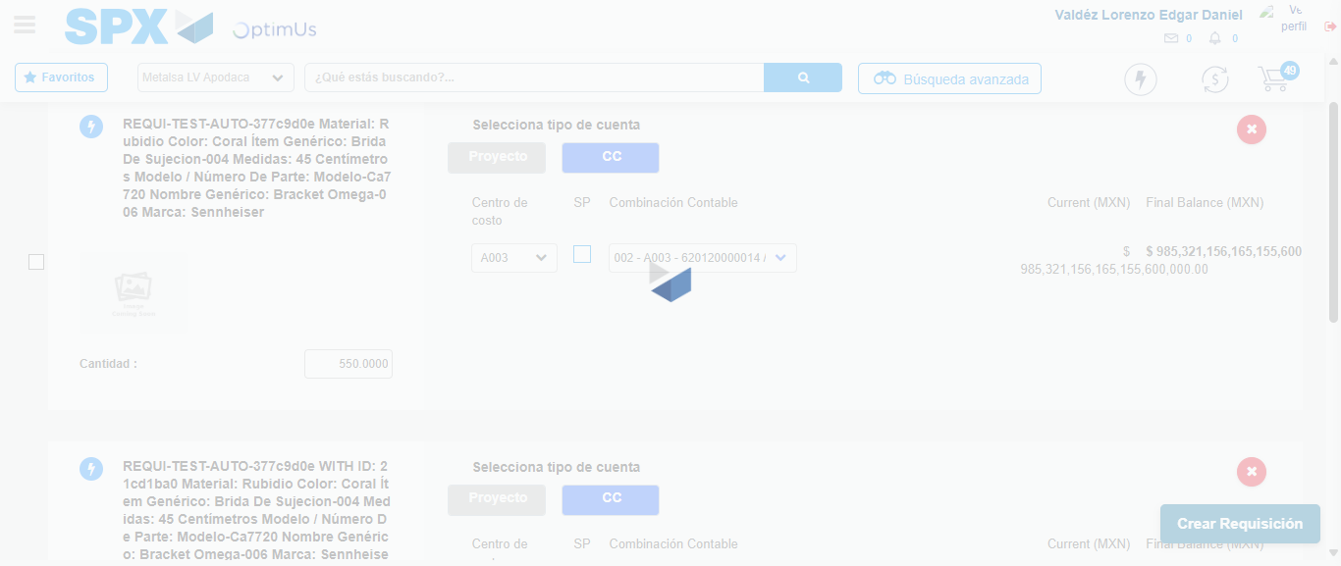Image file-name: QC_Testing-tc001_SPX_Dev5_Crear_Nueva_Linea_Requisicion_Spot_Tipo_Cobro_CC-1781315387001

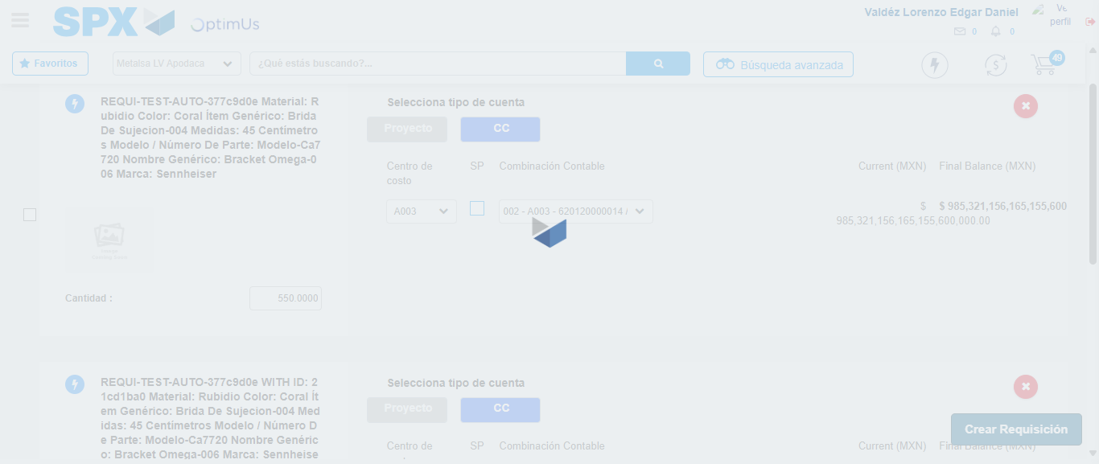Image file-name: QC_Testing-tc001_SPX_Dev5_Crear_Nueva_Linea_Requisicion_Spot_Tipo_Cobro_CC-1781315387218

Step 7 - Accept to Requisition: Requisition Accepted
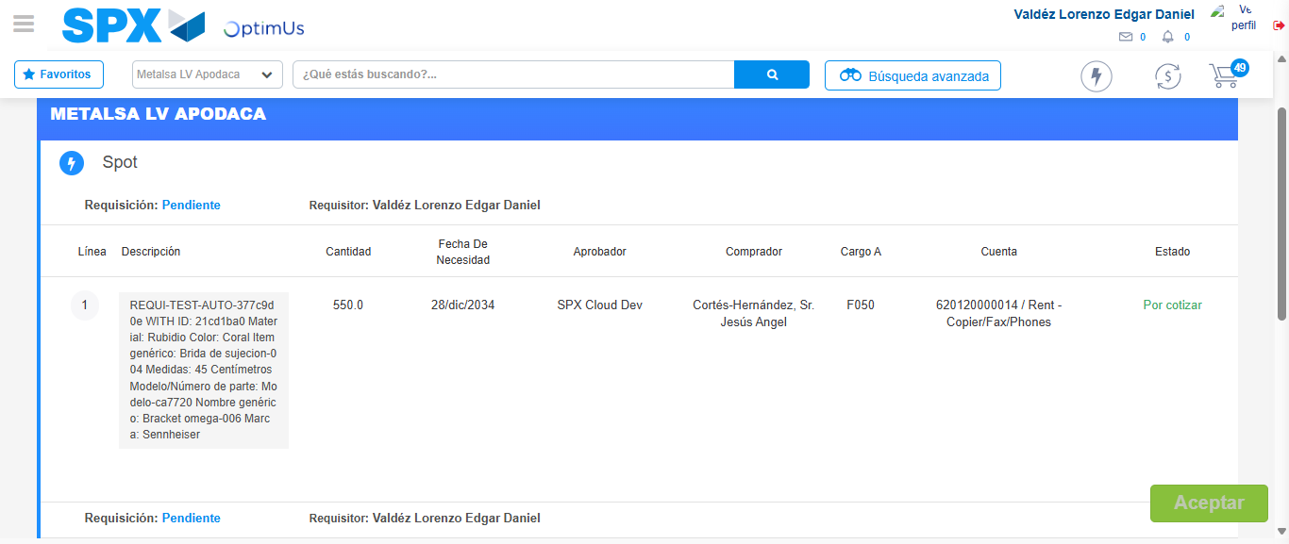Image file-name: QC_Testing-tc001_SPX_Dev5_Crear_Nueva_Linea_Requisicion_Spot_Tipo_Cobro_CC-1781315389045

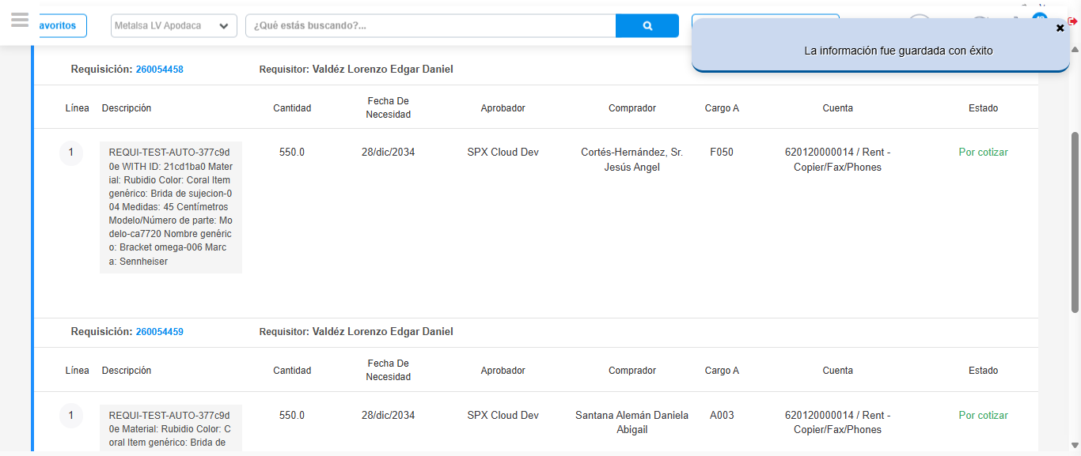Image file-name: QC_Testing-tc001_SPX_Dev5_Crear_Nueva_Linea_Requisicion_Spot_Tipo_Cobro_CC-1781315391546

Step 8 - Return to Main Page SPX : Return to Main Page SPX
Image file-name: QC_Testing-tc001_SPX_Dev5_Crear_Nueva_Linea_Requisicion_Spot_Tipo_Cobro_CC-1781315276676

Image file-name: QC_Testing-tc001_SPX_Dev5_Crear_Nueva_Linea_Requisicion_Spot_Tipo_Cobro_CC-1781315279401

Image file-name: QC_Testing-tc001_SPX_Dev5_Crear_Nueva_Linea_Requisicion_Spot_Tipo_Cobro_CC-1781315297889

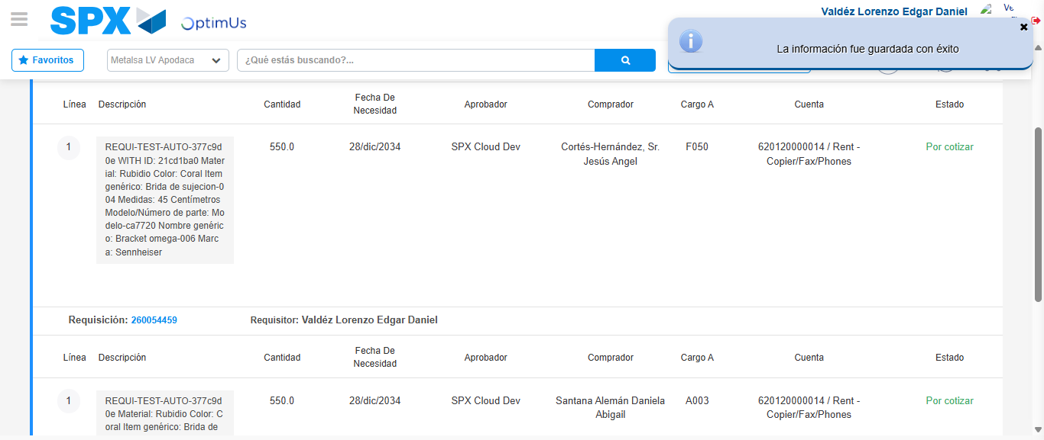Image file-name: QC_Testing-tc001_SPX_Dev5_Crear_Nueva_Linea_Requisicion_Spot_Tipo_Cobro_CC-1781315393764

Image file-name: QC_Testing-tc001_SPX_Dev5_Crear_Nueva_Linea_Requisicion_Spot_Tipo_Cobro_CC-1781315393944

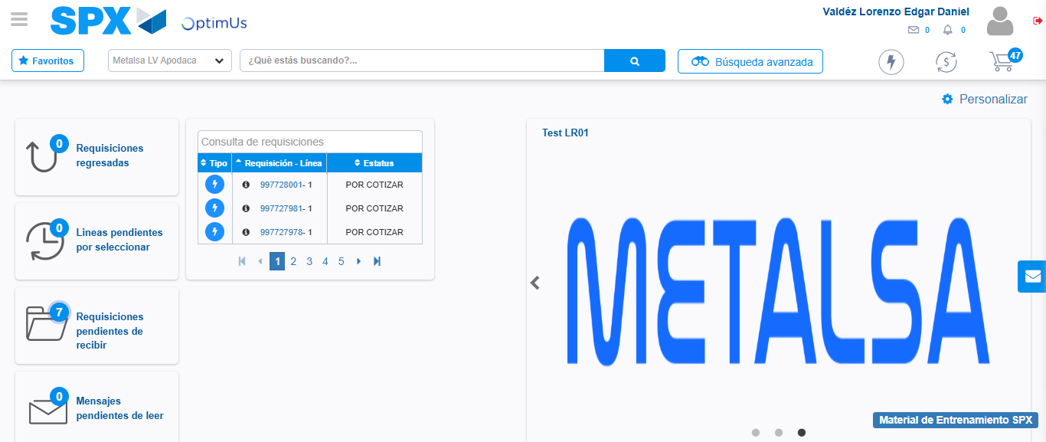Image file-name: QC_Testing-tc001_SPX_Dev5_Crear_Nueva_Linea_Requisicion_Spot_Tipo_Cobro_CC-1781315415060

Step 9 - Log Out : Log Out SPX
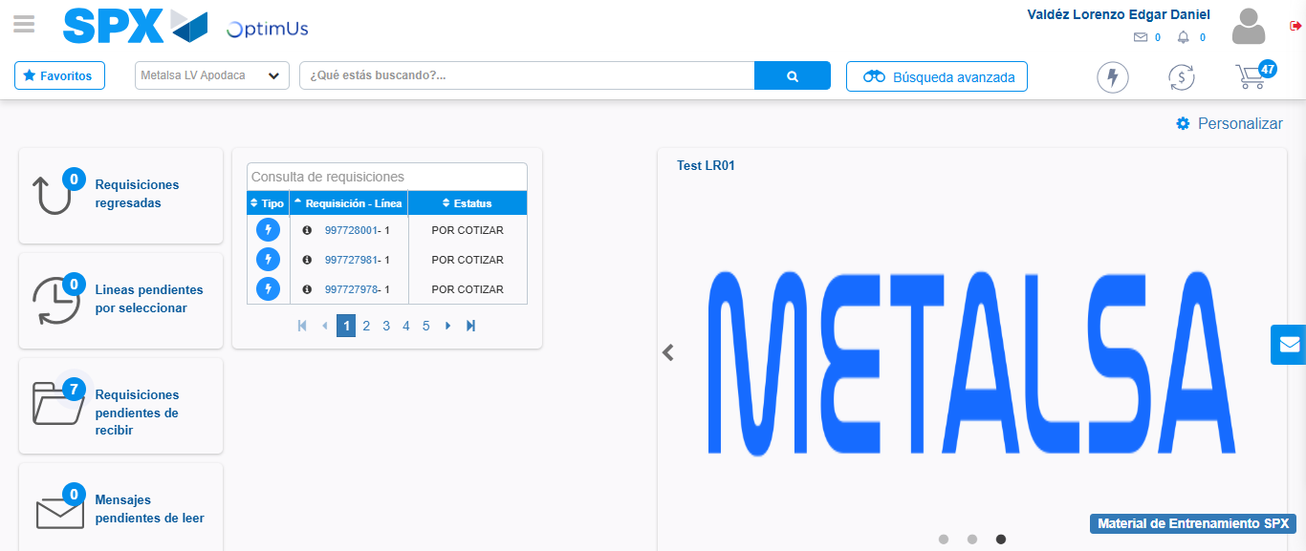Image file-name: QC_Testing-tc001_SPX_Dev5_Crear_Nueva_Linea_Requisicion_Spot_Tipo_Cobro_CC-1781315415303

